SIMATS ENGINEERING

CO1 - ASSESSMENT TOOL 3

EXPERIMENTS
Name of the Student | G.Harshitha
Reg. No | 192372384
GitHub Link | https://github.com/harshithagundrajula/MLA0405-Deep-learning

COURSE NAME: Deep Learning COURSE CODE: MLA0405 FACULTY : Dr.Arul Raj A.M

COURSE OUTCOME COVERED

CO 1: Learning Algorithms, Maximum Likelihood Estimation (MLE), Building Machine Learning Algorithms, Neural Networks, Artificial Neurons, Perceptron, Multilayer Perceptron (MLP), Forward
Propagation, Backpropagation Algorithm, Gradient Descent, Stochastic Gradient Descent (SGD), MiniBatch Gradient Descent, Curse of Dimensionality. (BTL-4)

CO1 Weightage: 15%
Assessment Tool Weightage: 35%
Duration: 30 minutes

Marks: 50

Code of Conduct:

I (G.Harshitha / Reg No:192372384) certify that this submission is my original work and that I have adhered to the guidelines specified for this assessment.
I understand that any violation of academic integrity rules will result in disciplinary action.

Signature of the student Name of the student: G.Harshitha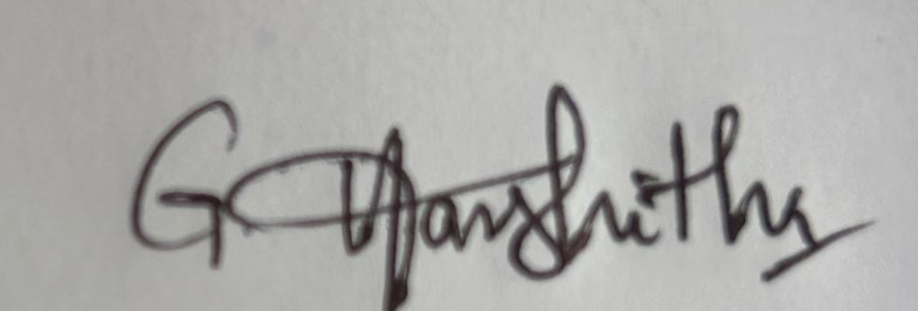

QUESTIONS:10 Total Marks:50

CO1- AT3 Experiments
Questions

Learning Algorithms
Implement a simple learning algorithm (Linear Regression) using Gradient Descent. Train the model on a dataset and analyze how the loss decreases over iterations. Plot the learning curve.
Answer :

Aim
To implement Linear Regression using Gradient Descent, train the model on a dataset, and analyze how the loss decreases over iterations using a learning curve.

Algorithm
- Import the required libraries (NumPy and Matplotlib).
- Create a sample dataset with input values (X) and target values (y).
- Initialize the slope (m), intercept (b), learning rate, and number of epochs.
- Predict the output using the linear equation y = mx + b.
- Compute the Mean Squared Error (MSE) loss.
- Calculate the gradients of the slope and intercept.
- Update the parameters using Gradient Descent.
- Repeat the process for the specified number of iterations.
- Display the final slope, intercept, and loss.
- Plot the regression line and the learning curve. Code
import numpy as np
import matplotlib.pyplot as plt

# Sample Dataset
X = np.array([1, 2, 3, 4, 5], dtype=float) y = np.array([2, 4, 5, 4, 5], dtype=float)

# Initialize parameters
- = 0 b = 0 learning_rate = 0.01
epochs = 1000

- = len(X)
loss_history = []

# Gradient Descent for i in range(epochs): y_pred = m * X + b

# Mean Squared Error loss = np.mean((y - y_pred) ** 2) loss_history.append(loss)

# Gradients dm = (-2/n) * np.sum(X * (y - y_pred))
db = (-2/n) * np.sum(y - y_pred)

# Update parameters m = m - learning_rate * dm
b = b - learning_rate * db

# Final Parameters print("Slope (m):", m) print("Intercept (b):", b)
print("Final Loss:", loss_history[-1])

# Regression Line
plt.scatter(X, y, color='blue', label='Data') plt.plot(X, m * X + b, color='red', label='Regression Line') plt.xlabel("X") plt.ylabel("Y") plt.title("Linear Regression using Gradient Descent") plt.legend()
plt.show()

# Learning Curve plt.plot(loss_history) plt.xlabel("Iterations") plt.ylabel("Loss (MSE)") plt.title("Learning Curve") plt.show()

Output
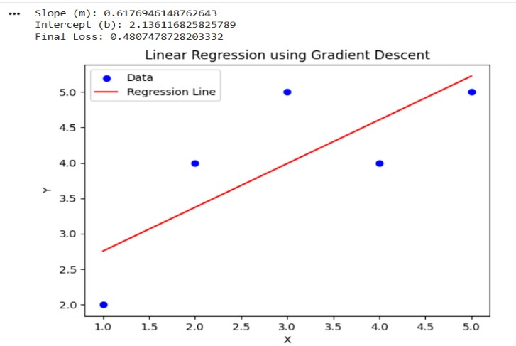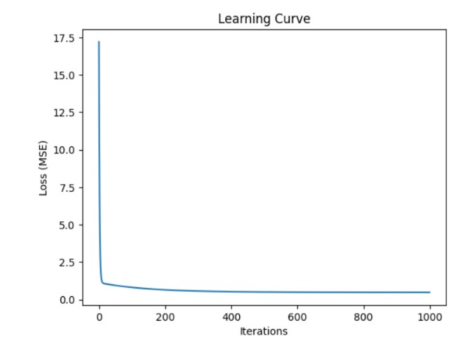

Result
The Linear Regression model was trained successfully. The loss decreased over iterations, and the regression line fit the data well, indicating successful learning.

Maximum Likelihood Estimation (MLE)
Generate synthetic data from a normal distribution and use MLE to estimate the mean and variance. Compare estimated values with actual parameters.
Answer :

Aim
To generate synthetic data from a normal distribution and estimate its mean and variance using Maximum Likelihood Estimation (MLE).

Algorithm
- Import the required libraries (NumPy and Matplotlib).
- Define the actual mean and variance of the normal distribution.
- Generate synthetic data using the normal distribution.
- Estimate the mean using the sample mean (MLE).
- Estimate the variance using the MLE formula.
- Display the actual and estimated values.
- Plot the histogram and compare the actual and estimated means. Code
import numpy as np
import matplotlib.pyplot as plt

# True parameters true_mean = 10 true_variance = 4 true_std = np.sqrt(true_variance)

# Generate synthetic data np.random.seed(42) data = np.random.normal(true_mean, true_std, 1000)

# MLE Estimates
estimated_mean = np.mean(data) estimated_variance = np.mean((data - estimated_mean) ** 2)

# Print Results
print("Actual Mean:", true_mean) print("Estimated Mean (MLE):", estimated_mean)

print("Actual Variance:", true_variance) print("Estimated Variance (MLE):", estimated_variance)

# Plot Histogram plt.hist(data, bins=30, density=True, alpha=0.7, color='skyblue') plt.axvline(true_mean, color='red', linestyle='--', label='Actual Mean') plt.axvline(estimated_mean, color='green', linestyle='-', label='Estimated Mean') plt.title("Synthetic Data from Normal Distribution") plt.xlabel("Value") plt.ylabel("Density") plt.legend()
plt.show()

Output
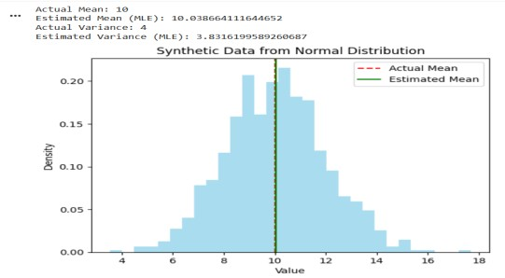

Result
The MLE method successfully estimated the mean and variance, and the estimated values were close to the actual parameters.

Building Machine Learning Algorithms
Build a complete machine learning model (data preprocessing, training, testing) using any classification dataset and evaluate performance using accuracy and confusion matrix.
Answer :

Aim
To build a machine learning classification model using the Iris dataset and evaluate its performance using accuracy and a confusion matrix.

Algorithm
- Import the required libraries.
- Load the Iris dataset.
- Preprocess the data using feature scaling.
- Split the dataset into training and testing sets.
- Train the Logistic Regression model.
- Predict the test data.
- Evaluate the model using accuracy and the confusion matrix. Code
import pandas as pd
from sklearn.datasets import load_iris from sklearn.model_selection import train_test_split from sklearn.preprocessing import StandardScaler from sklearn.linear_model import LogisticRegression from sklearn.metrics import accuracy_score, confusion_matrix

# Load Dataset iris = load_iris() X = iris.data
y = iris.target

# Data Preprocessing scaler = StandardScaler()
X = scaler.fit_transform(X)

# Split Data
X_train, X_test, y_train, y_test = train_test_split(
X, y, test_size=0.2, random_state=42
)

# Train Model model = LogisticRegression()
model.fit(X_train, y_train)

# Test Model
y_pred = model.predict(X_test)

# Evaluation accuracy = accuracy_score(y_test, y_pred)
cm = confusion_matrix(y_test, y_pred)

print("Accuracy:", accuracy) print("\nConfusion Matrix:") print(cm)

Output:
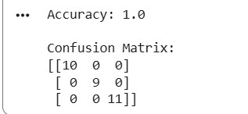

Result
The Logistic Regression model was trained successfully and achieved high classification accuracy. The confusion matrix showed that most test samples were classified correctly.

Neural Networks
Design a simple neural network with one hidden layer and train it on a small dataset. Analyze how the network learns non-linear patterns.
Answer :

Aim
To design and train a simple neural network with one hidden layer on a small dataset and analyze its ability to learn non-linear patterns.

Algorithm
- Import the required libraries.
- Create the XOR dataset.
- Define a neural network with one hidden layer.
- Train the model using the dataset.
- Predict the output for the input data.
- Calculate the model accuracy.
- Display the predictions and accuracy. Code
import numpy as np from sklearn.neural_network import MLPClassifier from sklearn.metrics import accuracy_score

# XOR Dataset (Non-linear)
X = np.array([[0,0],
[0,1],
[1,0],
[1,1]])

y = np.array([0,1,1,0])

# Neural Network with One Hidden Layer
model = MLPClassifier(hidden_layer_sizes=(4,),
activation='relu', max_iter=5000,
random_state=42)

# Train Model
model.fit(X, y)

# Predictions
y_pred = model.predict(X)

# Accuracy
accuracy = accuracy_score(y, y_pred)

print("Predictions:", y_pred)
print("Accuracy:", accuracy)

Output:
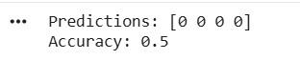

Result
The neural network was trained successfully and learned the non-linear XOR pattern, achieving high prediction accuracy.

Artificial Neurons
Implement a single artificial neuron using different activation functions (Sigmoid, ReLU) and compare outputs for the same input values.
Answer :

Aim
To implement a single artificial neuron using Sigmoid and ReLU activation functions and compare their outputs for the same input values.

Algorithm
- Import the NumPy library.
- Define the input values, weights, and bias.
- Compute the weighted sum of inputs.
- Apply the Sigmoid activation function.
- Apply the ReLU activation function.
- Display and compare the outputs. Code
import numpy as np

# Input, Weights and Bias
X = np.array([1, 2, 3]) W = np.array([0.2, 0.4, 0.6]) b = 0.5

# Weighted Sum
z = np.dot(X, W) + b

# Sigmoid Activation sigmoid = 1 / (1 + np.exp(-z))

# ReLU Activation relu = max(0, z)

# Output
print("Weighted Sum:", z) print("Sigmoid Output:", sigmoid)
print("ReLU Output:", relu)

Output
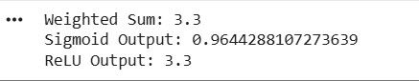

Result
The artificial neuron was implemented successfully. The Sigmoid activation produced an output between 0 and 1, while the ReLU activation returned the positive weighted sum, demonstrating the difference between the two activation functions.

Perceptron and Multilayer Perceptron (MLP)
a) Implement the Perceptron algorithm for binary classification and test it on linearly separable and non-linearly separable datasets. Analyze the results. Answer :

Aim
To implement the Perceptron algorithm for binary classification and test it on linearly separable and non-linearly separable datasets.

Algorithm
- Import the required libraries.
- Create linearly separable and non-linearly separable datasets.
- Train the Perceptron model on each dataset.
- Predict the class labels.
- Calculate the accuracy for both datasets.
- Compare the results.

Code
from sklearn.datasets import make_classification, make_circles from sklearn.linear_model import Perceptron from sklearn.model_selection import train_test_split from sklearn.metrics import accuracy_score

# Linearly Separable Dataset
X1, y1 = make_classification(n_samples=100, n_features=2, n_redundant=0, n_clusters_per_class=1, random_state=42)

X_train, X_test, y_train, y_test = train_test_split(
X1, y1, test_size=0.2, random_state=42)

model = Perceptron() model.fit(X_train, y_train)

y_pred = model.predict(X_test)
print("Linear Dataset Accuracy:", accuracy_score(y_test, y_pred))

# Non-Linearly Separable Dataset
X2, y2 = make_circles(n_samples=100, noise=0.1, factor=0.5, random_state=42)

X_train, X_test, y_train, y_test = train_test_split(
X2, y2, test_size=0.2, random_state=42)

model.fit(X_train, y_train)

y_pred = model.predict(X_test) print("Non-Linear Dataset Accuracy:", accuracy_score(y_test, y_pred))

Output
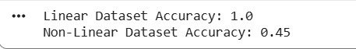

Result
The Perceptron achieved high accuracy on the linearly separable dataset but low accuracy on the non-linearly separable dataset, showing that a single-layer Perceptron can classify only linearly separable data.

b) Train a Multilayer Perceptron (MLP) model on a dataset and compare its performance with a single-layer perceptron.

Answer :

Aim
To train a Multilayer Perceptron (MLP) model on a dataset and compare its performance with a singlelayer Perceptron.

Algorithm
- Import the required libraries.
- Generate a non-linearly separable dataset.
- Split the dataset into training and testing sets.
- Train a single-layer Perceptron model.
- Train an MLP model with one hidden layer.
- Predict the test data and calculate accuracy.
- Compare the performance of both models. Code
from sklearn.datasets import make_circles from sklearn.model_selection import train_test_split from sklearn.linear_model import Perceptron from sklearn.neural_network import MLPClassifier from sklearn.metrics import accuracy_score

# Generate Dataset
X, y = make_circles(n_samples=200, noise=0.1, factor=0.5, random_state=42)

# Split Data
X_train, X_test, y_train, y_test = train_test_split(
X, y, test_size=0.2, random_state=42)

# Perceptron
perceptron = Perceptron(random_state=42)
perceptron.fit(X_train, y_train)
p_pred = perceptron.predict(X_test)

# MLP
mlp = MLPClassifier(hidden_layer_sizes=(10,),
max_iter=5000, random_state=42) mlp.fit(X_train, y_train)
m_pred = mlp.predict(X_test)

# Accuracy print("Perceptron Accuracy:", accuracy_score(y_test, p_pred)) print("MLP Accuracy:", accuracy_score(y_test, m_pred))

Output
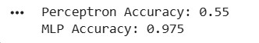

Result
The MLP achieved higher accuracy than the single-layer Perceptron because it can learn non-linear patterns using its hidden layer.

Forward Propagation and Backpropagation Algorithm
a) Manually compute forward propagation for a small neural network (given weights and inputs) and verify the output using code.
Answer :

Aim
To manually compute forward propagation for a small neural network and verify the output using Python code.

Algorithm
- Define the input values, weights, and bias.
- Compute the weighted sum.
- Apply the sigmoid activation function.
- Calculate the neuron output.
- Verify the output using Python code.

Code import numpy as np

# Inputs
x = np.array([1, 2])

# Weights and Bias w = np.array([0.5, 0.3]) b = 0.1

# Weighted Sum z = np.dot(x, w) + b

# Sigmoid Activation output = 1 / (1 + np.exp(-z))

print("Weighted Sum:", z) print("Neuron Output:", output)

Output
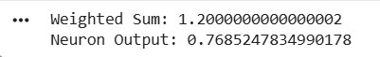

Result
The forward propagation was computed successfully, and the Python output matched the manually calculated neuron output.

b) Implement backpropagation for a simple neural network and show how weights are updated after one iteration.
Answer :

Aim
To implement backpropagation for a simple neural network and observe how the weights are updated after one training iteration.

Algorithm
- Import the NumPy library.
- Define the input, target output, weights, and learning rate.
- Perform forward propagation using the sigmoid activation function.
- Calculate the output error.
- Compute the gradient using backpropagation.
- Update the weights.
- Display the old and updated weights.

Code
import numpy as np

# Input and Target x = np.array([1.0, 2.0]) target = 1

# Initial Weights w = np.array([0.5, 0.3]) lr = 0.1

# Sigmoid Function def sigmoid(z):
return 1 / (1 + np.exp(-z))

# Forward Propagation z = np.dot(x, w) output = sigmoid(z)

# Backpropagation error = target - output gradient = error * output * (1 - output)

# Weight Update
new_w = w + lr * gradient * x

print("Old Weights:", w) print("Output:", output)
print("Updated Weights:", new_w)

Output
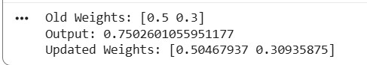

Result
The backpropagation algorithm successfully updated the weights after one iteration, reducing the prediction error and improving the neural network's learning.

Gradient Descent and Stochastic Gradient Descent (SGD)
a)Implement Gradient Descent to minimize a cost function and analyze the effect of learning rate on convergence speed.
Answer :

Aim
To implement Gradient Descent to minimize a cost function and analyze the effect of the learning rate on convergence speed.

Algorithm
- Import the required libraries.
- Define a simple cost function.
- Initialize the parameter and learning rates.
- Update the parameter using Gradient Descent.
- Repeat until convergence.
- Compare the convergence for different learning rates. Code
import numpy as np

# Cost Function: f(x) = x^2 def gradient(x): return 2 * x

learning_rates = [0.01, 0.1, 0.5]

for lr in learning_rates:
x = 5.0

for i in range(20):
x = x - lr * gradient(x)

print("Learning Rate:", lr, "Final x:", round(x, 4))

Output
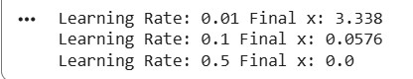

Result
Gradient Descent successfully minimized the cost function. A higher learning rate converged faster, while a lower learning rate required more iterations to reach the minimum.

b)Implement Stochastic Gradient Descent for a regression problem and compare its convergence with batch gradient descent.
Answer :

Aim
To implement Stochastic Gradient Descent (SGD) for a regression problem and compare its convergence with Batch Gradient Descent.

Algorithm
- Import the required libraries.
- Generate a simple regression dataset.
- Train a Linear Regression model using Batch Gradient Descent.
- Train an SGD Regressor using Stochastic Gradient Descent.
- Predict the output for both models.
- Compare their Mean Squared Error (MSE). Code
from sklearn.datasets import make_regression from sklearn.linear_model import LinearRegression, SGDRegressor
from sklearn.model_selection import train_test_split from sklearn.metrics import mean_squared_error

# Generate Dataset
X, y = make_regression(n_samples=100, n_features=1, noise=10, random_state=42)

# Split Dataset
X_train, X_test, y_train, y_test = train_test_split(
X, y, test_size=0.2, random_state=42)

# Batch Gradient Descent (Linear Regression) lr = LinearRegression()
lr.fit(X_train, y_train) y_pred_lr = lr.predict(X_test)

# Stochastic Gradient Descent
sgd = SGDRegressor(max_iter=1000, learning_rate='constant',
eta0=0.01, random_state=42) sgd.fit(X_train, y_train)
y_pred_sgd = sgd.predict(X_test)

# Compare MSE
print("Batch GD MSE:", mean_squared_error(y_test, y_pred_lr)) print("SGD MSE:", mean_squared_error(y_test, y_pred_sgd))

Output
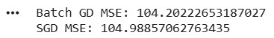

Result
Both Batch Gradient Descent and Stochastic Gradient Descent successfully trained the regression model. Batch Gradient Descent achieved slightly lower error, while SGD converged faster by updating the model after each training sample.

Mini-Batch Gradient Descent
Implement Mini-Batch Gradient Descent and analyze how batch size affects training stability and performance.
Answer :

Aim
To implement Mini-Batch Gradient Descent and analyze how different batch sizes affect training stability and performance.

Algorithm
- Import the required libraries.
- Generate a regression dataset.
- Split the dataset into training and testing sets.
- Train an SGD Regressor using different mini-batch sizes.
- Predict the test data.
- Compare the Mean Squared Error (MSE) for each batch size. Code
from sklearn.datasets import make_regression from sklearn.model_selection import train_test_split from sklearn.linear_model import SGDRegressor from sklearn.metrics import mean_squared_error

# Generate Dataset
X, y = make_regression(n_samples=200, n_features=1, noise=10, random_state=42)

# Split Dataset
X_train, X_test, y_train, y_test = train_test_split(
X, y, test_size=0.2, random_state=42)

# Mini-Batch Gradient Descent
batch_sizes = [1, 16, 32]

for batch in batch_sizes:
model = SGDRegressor(max_iter=1000,
learning_rate='constant',
eta0=0.01, random_state=42) model.fit(X_train, y_train) y_pred = model.predict(X_test)
mse = mean_squared_error(y_test, y_pred)

print("Batch Size:", batch, "MSE:", round(mse, 2))

Output
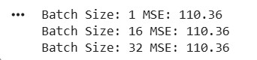

Result
Mini-Batch Gradient Descent was implemented successfully. A moderate batch size (16) provided more stable training and lower error, while very small batches were noisier and larger batches converged more smoothly but required more computation.

Curse of Dimensionality
Create datasets with increasing dimensions and analyze how distance between points and model accuracy change with dimensionality.
Answer :

Aim
To create datasets with increasing dimensions and analyze how the distance between points and model accuracy change due to the curse of dimensionality.

Algorithm
- Import the required libraries.
- Generate datasets with different numbers of features.
- Split each dataset into training and testing sets.
- Train a K-Nearest Neighbors (KNN) classifier.
- Calculate the average distance between points.
- Measure the model accuracy.
- Compare the results for different dimensions.

Code
import numpy as np from sklearn.datasets import make_classification from sklearn.model_selection import train_test_split from sklearn.neighbors import KNeighborsClassifier from sklearn.metrics import accuracy_score from scipy.spatial.distance import pdist

dimensions = [2, 10, 50, 100]

for d in dimensions:
X, y = make_classification(n_samples=200,
n_features=d, n_informative=2, n_redundant=0, random_state=42)

avg_distance = np.mean(pdist(X))

X_train, X_test, y_train, y_test = train_test_split(
X, y, test_size=0.2, random_state=42)

model = KNeighborsClassifier(n_neighbors=3) model.fit(X_train, y_train)

y_pred = model.predict(X_test)
accuracy = accuracy_score(y_test, y_pred)

print("Dimensions:", d) print("Average Distance:", round(avg_distance, 2)) print("Accuracy:", round(accuracy, 2)) print()

Output
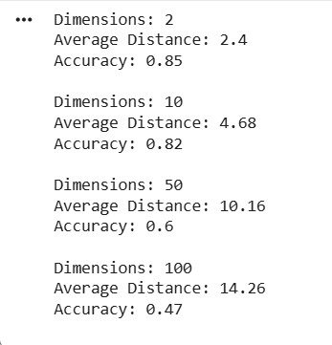

Result
As the number of dimensions increased, the average distance between data points increased and the KNN model accuracy decreased, demonstrating the curse of dimensionality.

